# REPORT

Title: F1-PULSE

Team: Pulse

Team Members: Tyleyeva Amina (IT-2402), Ikhsanova Aziza (IT-2402), Zhussupbekova Zere (IT-2401), Moldash Anel (IT-2401).

**Project Goal and Description**

The goal of this project was to design and develop a fully interactive, multi-page Formula 1 fan website named F1-Pulse. The website aims to provide an immersive and cinematic experience and big base of basic information for F1 enthusiasts by presenting driver profiles, team information, race circuits, and upcoming events in a visually striking and engaging format.

Inspired by the aesthetic of intelligence agencies (e.g., KGB/CIA dossier style), the site combines dark-themed design with dynamic interactions to deliver a unique user experience that goes beyond a standard sports website. We also used colours of finish line (red/blackwhite), so fans could feel the real aesthetic.

In technical plan, this project demonstrates comprehensive knowledge of modern web development technologies, including HTML5, CSS3, Bootstrap 5 for responsive layout, and JavaScript/jQuery for interactivity, all while adhering to the principles of responsive design and semantic coding.

**Notes:**

1.**Formula** **One**, commonly abbreviated as **F1**, is the highest class of international racing for open-wheel single-seater formula racing cars sanctioned by the Fédération Internationale de l'Automobile (FIA). The FIA **Formula** **One** World Championship has been one of the world's premier forms of motorsport since **its** inaugural running in 1950. The word formula in the name refers to the set of rules all participants' cars must follow.

2.**You may ask why “F1-Pulse”?**

Here our answer:"F1 Pulse" was chosen deliberately to capture the essence and energy of Formula 1 racing.Just like a **human pulse** is the **rhythmic beat of the heart** that signifies **life**, **energy**, and **intensity**, Formula 1 has it`s own "pulse"-a constant, thrilling rhythm of speed, strategy, and competition that drives the sport forward.

Like, **Pulse=Heartbeat of the Sport**:  
 **F1 is not just about cars; it’s a living, breathing ecosystem of teams, drivers, engineers, and millions of fans worldwide. "F1 Pulse" represents this central heartbeah-the core energy that connects everyone involved.**

**Pulse=Rhythm of the Race**:   
 From **the roar of the engines** at the start to the tension of pit stops and the final lap, every Grand Prix has a **unique rhythm**-a pulse that accelerates and decelerates with every overtake and strategy call.

**Pulse=Real-Time Excitement**:  
 The word "pulse" also implies immediacy and real-time action- exactly what F1 delivers. **Our website aims to give fans a direct line to this excitement, making them feel the sport’s pulse as if they were trackside.**

In short, "F1 Pulse" is more than a name-it’s a promise to deliver the living, beating heart of Formula 1 to every visitor.(we really tried)

**3.** If you want to feel the vibe of Formula 1, we recommend you to watch film “Formula 1”(2025)(but they forgot that FIA exists))).

**3. Work Division**

This project was completed by 4 of us:

* Concept, Design: Creation of the F1-Pulse concept, colour scheme (dark theme with F1 red accents), typography (Orbitron for headings, Roboto for body), and overall user interface idea was made by Amina.
* Front-End Development: Writing all HTML, CSS, and JavaScript/jQuery code for a 5-page website-everyone, detailed:

Home page-Zere.

Teams - Aziza

Drivers-Amina

Tracks-Zere

News-Anel

Shop-Aziza

* Interactive Features: Implementation of modal windows for driver dossiers, fade-in animations in Tracks, Teams and e.t.c, Current weather, PlaceGPS, form validation, and dynamic content loading.(all of us worked hard here)
* Responsive Design: Ensuring the website is fully responsive across desktop, tablet, and mobile devices using the Bootstrap 12-column grid system.
* Testing and Debugging: Comprehensive testing of all functionalities and cross-browser/device compatibility using Live Server and browser developer tools.
* Documentation: Preparation of this report and creation of project files for submission was made by Amina.

**4. Detailed Explanation of Website**

The F1-Pulse website consists of six logically connected pages, each serving a specific purpose and maintaining a consistent design language.

Main Pages and Functionalities:

1. Home Page (index.html):
   * Functionality: Serves as the main entry point with a live banner, from which just by clicking on Navigation bar or on buttons people may see any other information.
   * Design: Features a full-width banner with a finish-line inspired background. Uses custom CSS for a sleek, modern look.
   * There is F1 Stats Snapshot, Trending Drivers, TOP Teams, Latest Pomiums, Engine Share, Coordinates of the Next Race, Weather there, Countdown and one random interesting quote of all F1 Drivers from many at the end of the page. Footer for easy direction to any page.

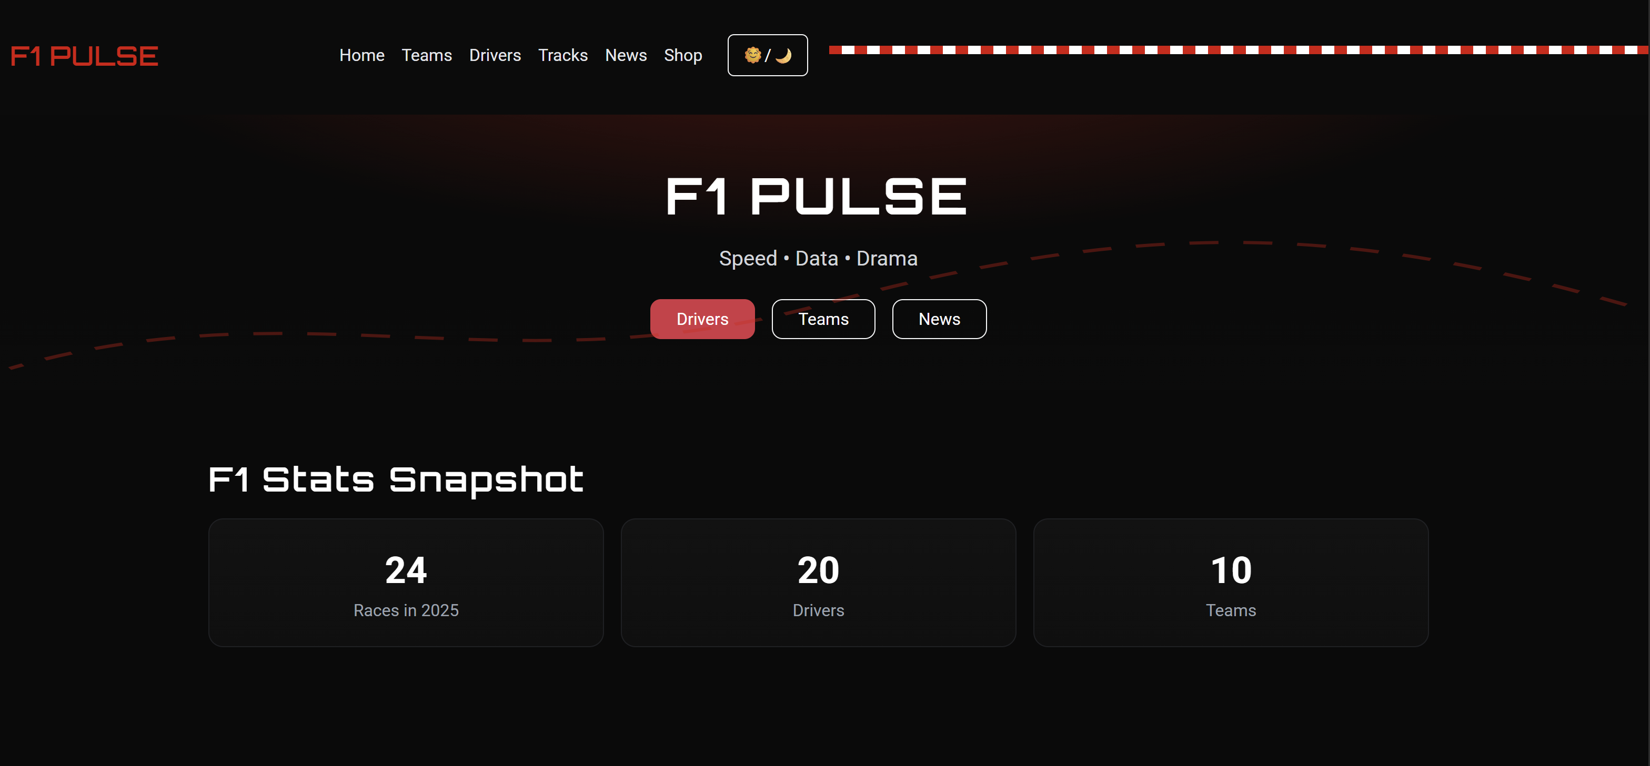

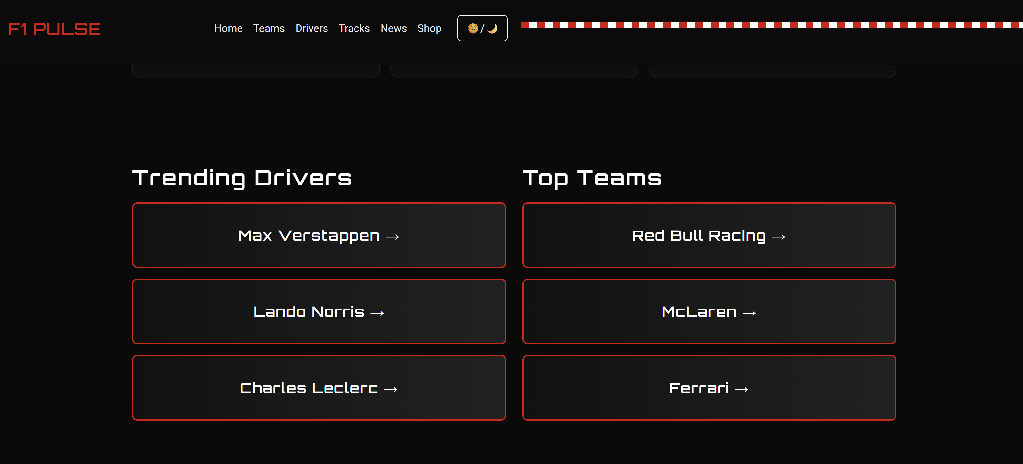

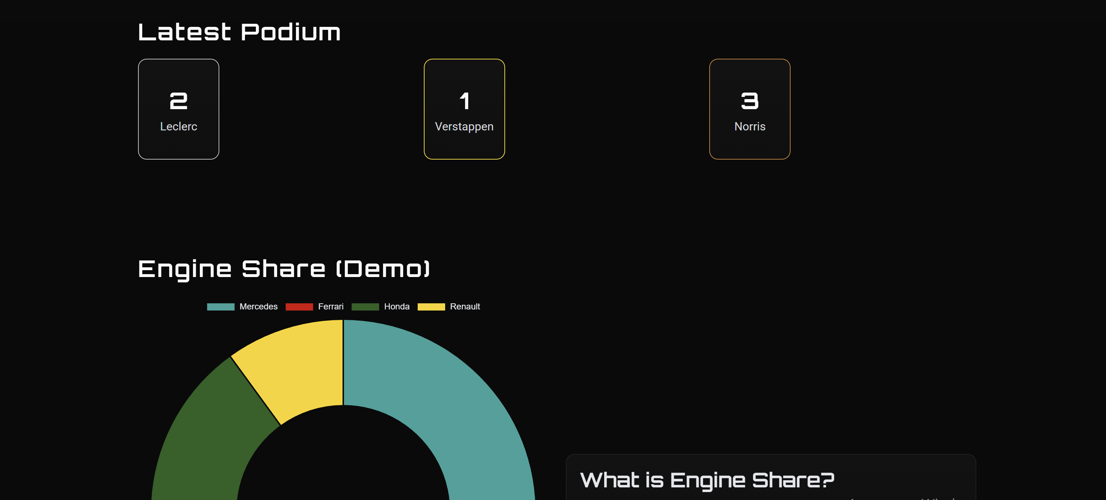

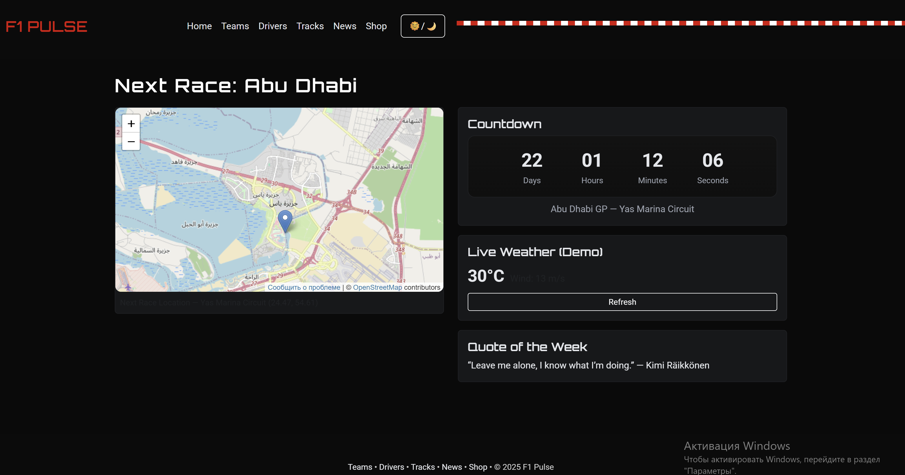

1. Teams Page (teams.html):
   * Functionality: Displays all F1 teams in a responsive grid. Each team card is clickable, there you can see bolid, drivers and if needed leads to the Drivers page.
   * Design: Utilizes the Bootstrap grid system to ensure a clean, 3-column layout on desktop that gracefully collapses to 1 column on mobile.

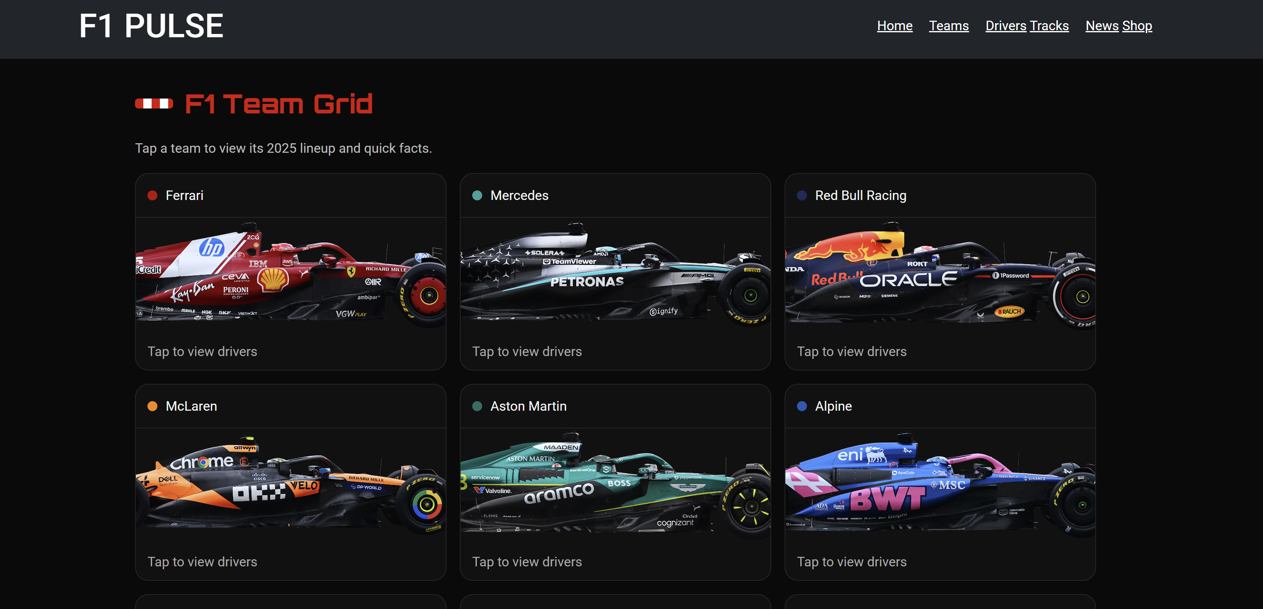

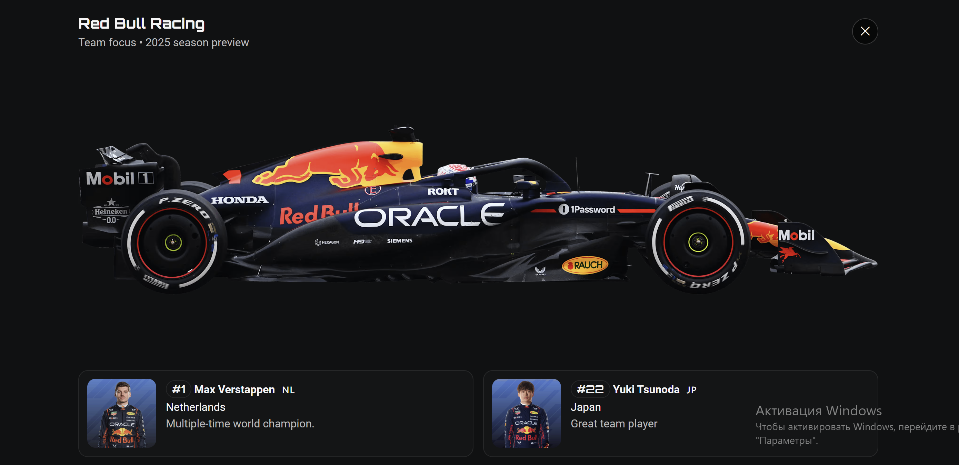

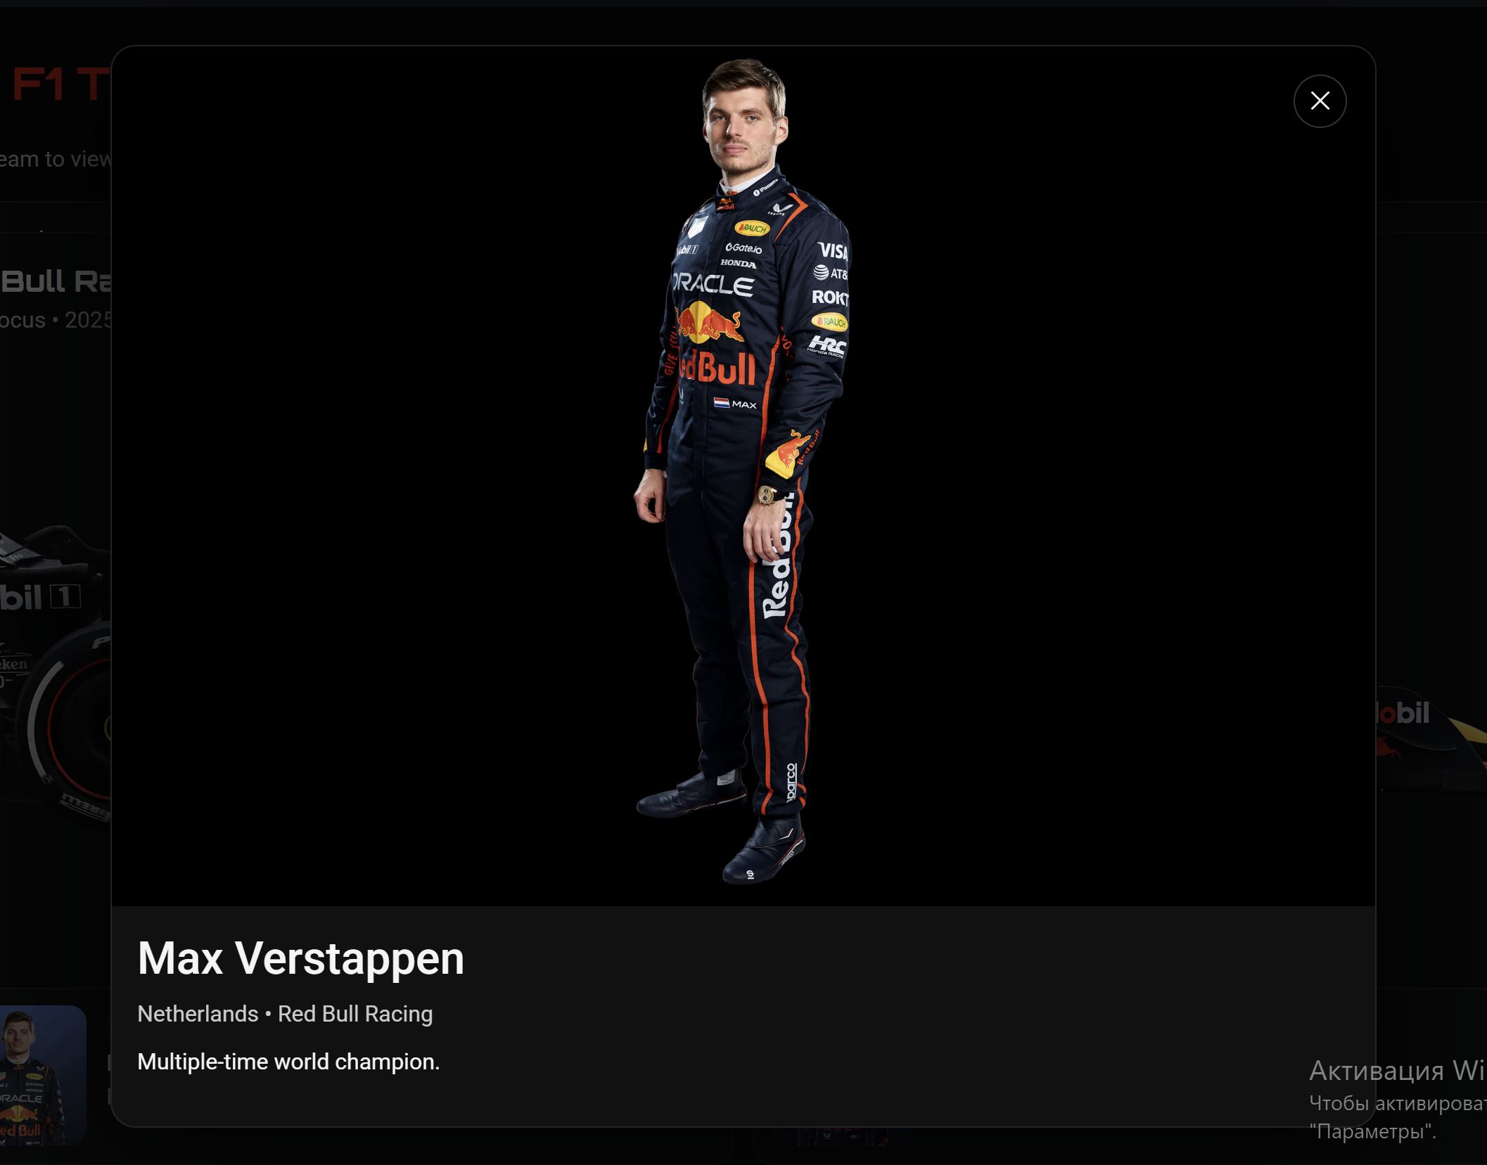

1. Drivers Page (drivers.html):
   * Functionality: Users can select a driver from a list of full-size cards. Upon clicking a card, a modal window opens, styled as a classified intelligence dossier.
   * Key Features:
     + The dossier dynamically displays the driver's photo, full name, nationality, team, race number, and biography.
     + It shows the driver's birth date and current age (e.g., "30 Sep 1997 (28 years)").
     + It includes the driver's zodiac sign with a corresponding symbol (e.g., "Libra ♎").
     + A unique audio clip for each driver plays upon opening the dossier and stops when it is closed.
   * Design: The modal features a dark background, red borders, a "TOP SECRET" stamp, and Orbitron font to create a cinematic, spy-agency feel.
   * Then at the end of the page some interactive named “F1 Meme Reveal”/Your F1 meme and Footer.

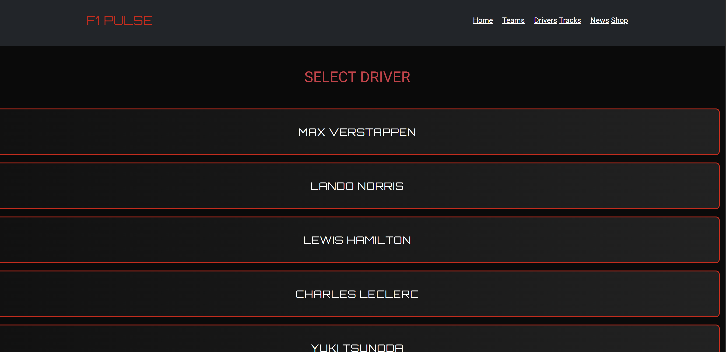

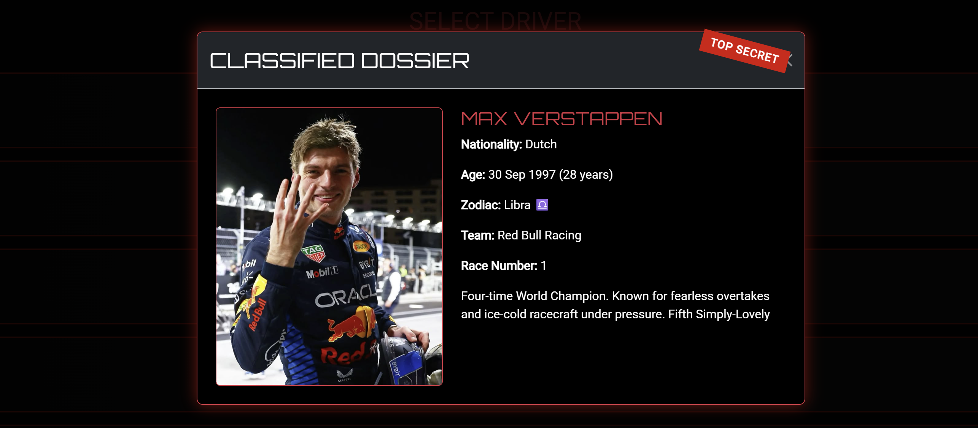

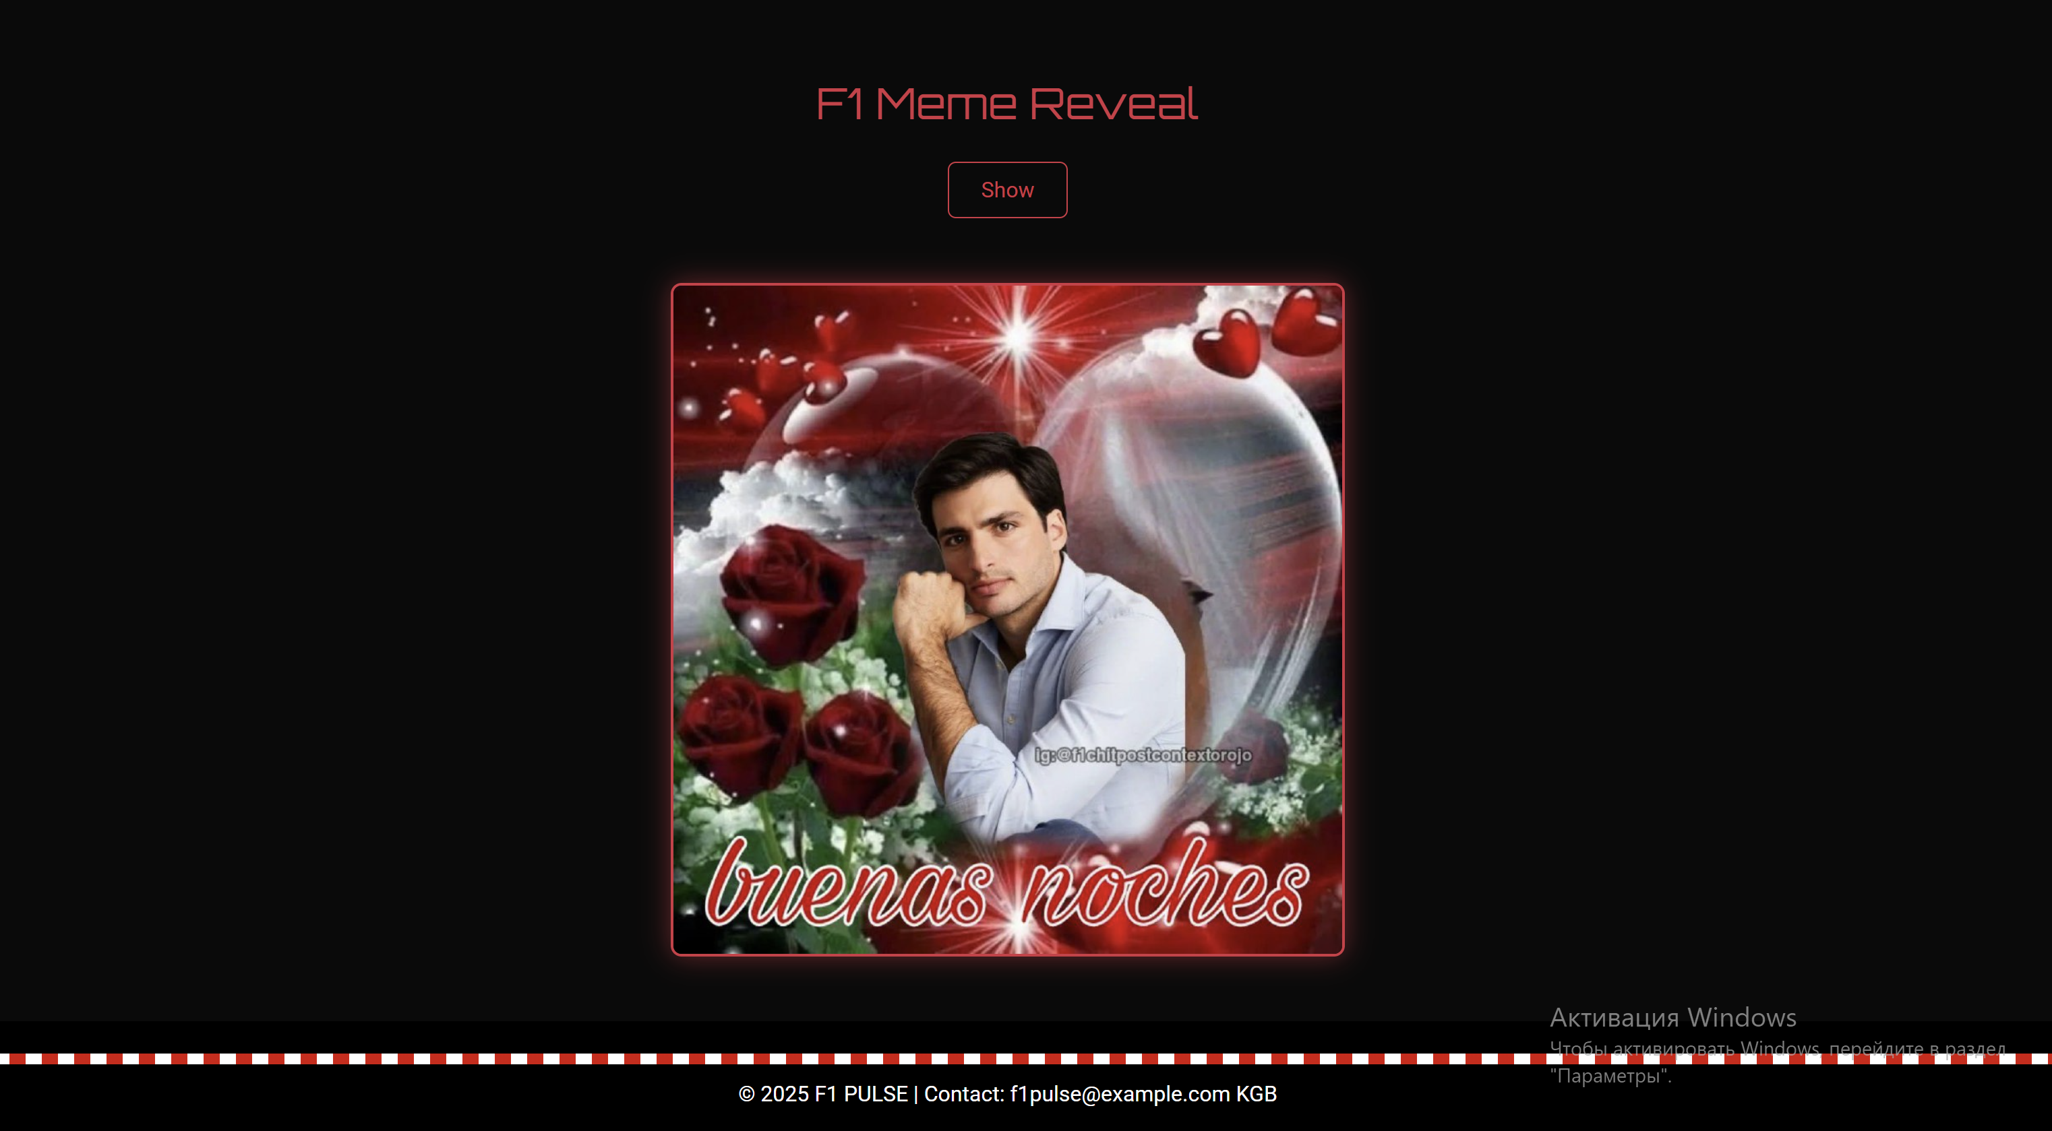

1. Tracks Page (tracks.html):
   * Functionality: Displays a gallery of all F1 circuits for the 2025 season. Clicking on a track thumbnail opens a modal with a larger image, a description, date, circuit map and who took pole positions.
   * Design: A responsive image gallery using Bootstrap cards for an organized and visually appealing layout.

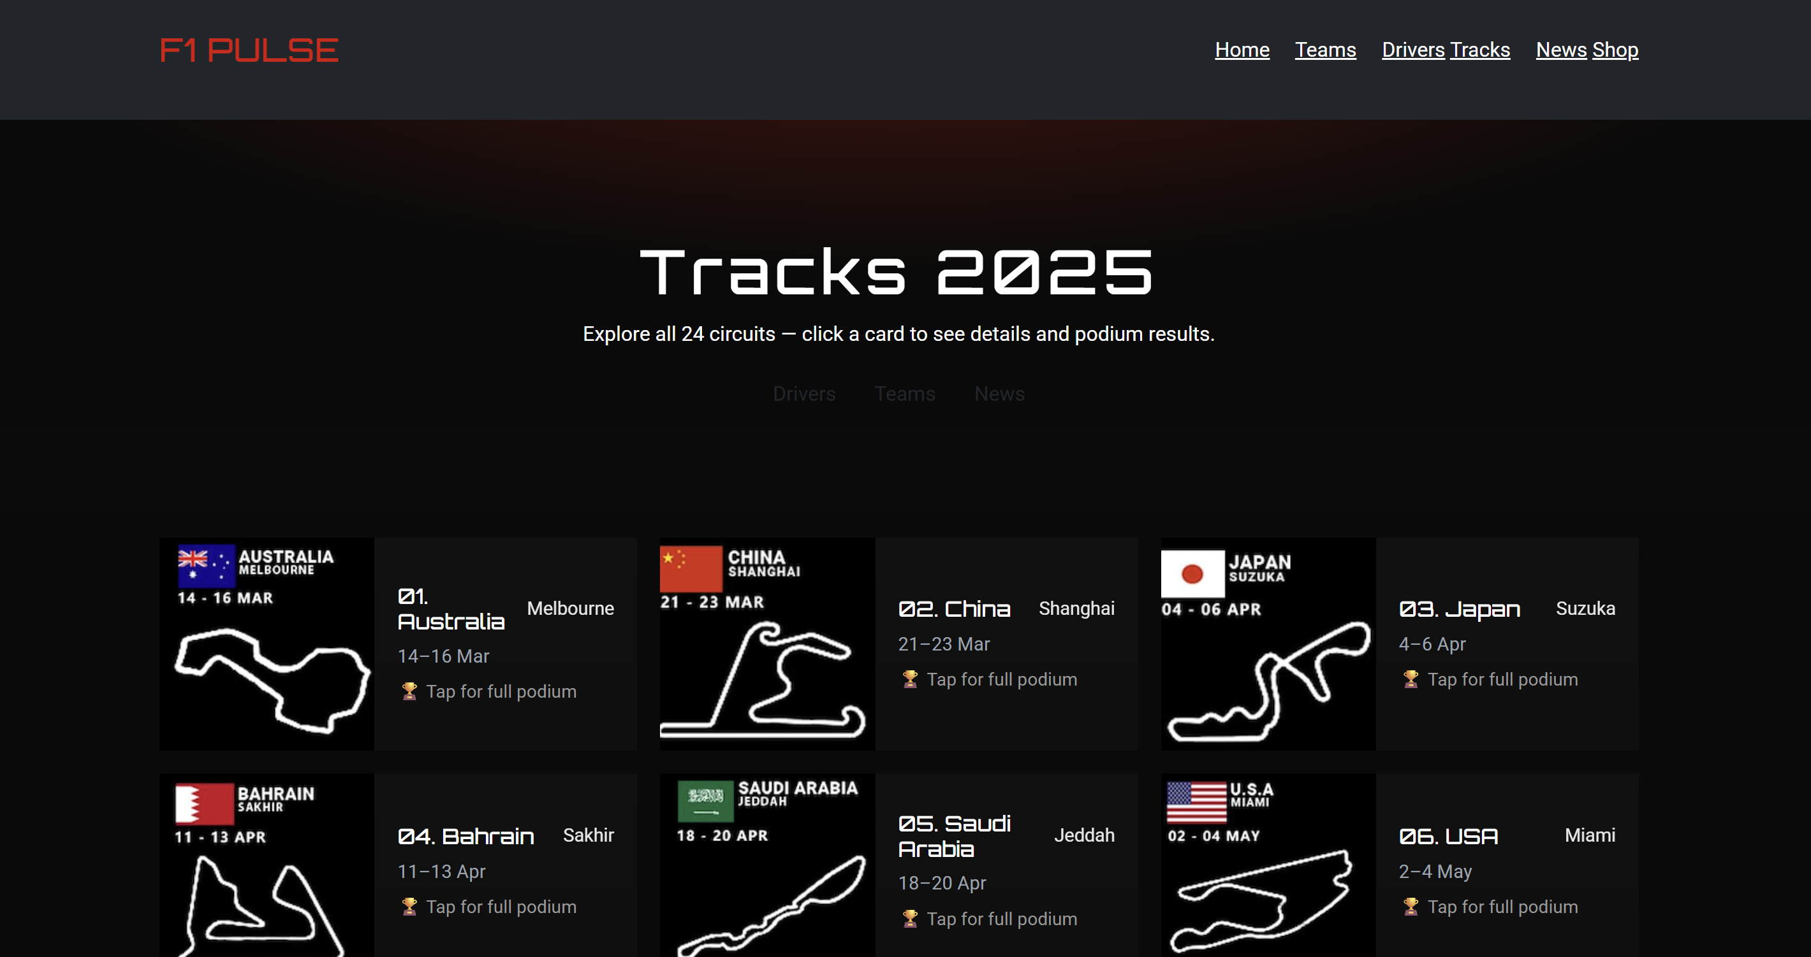

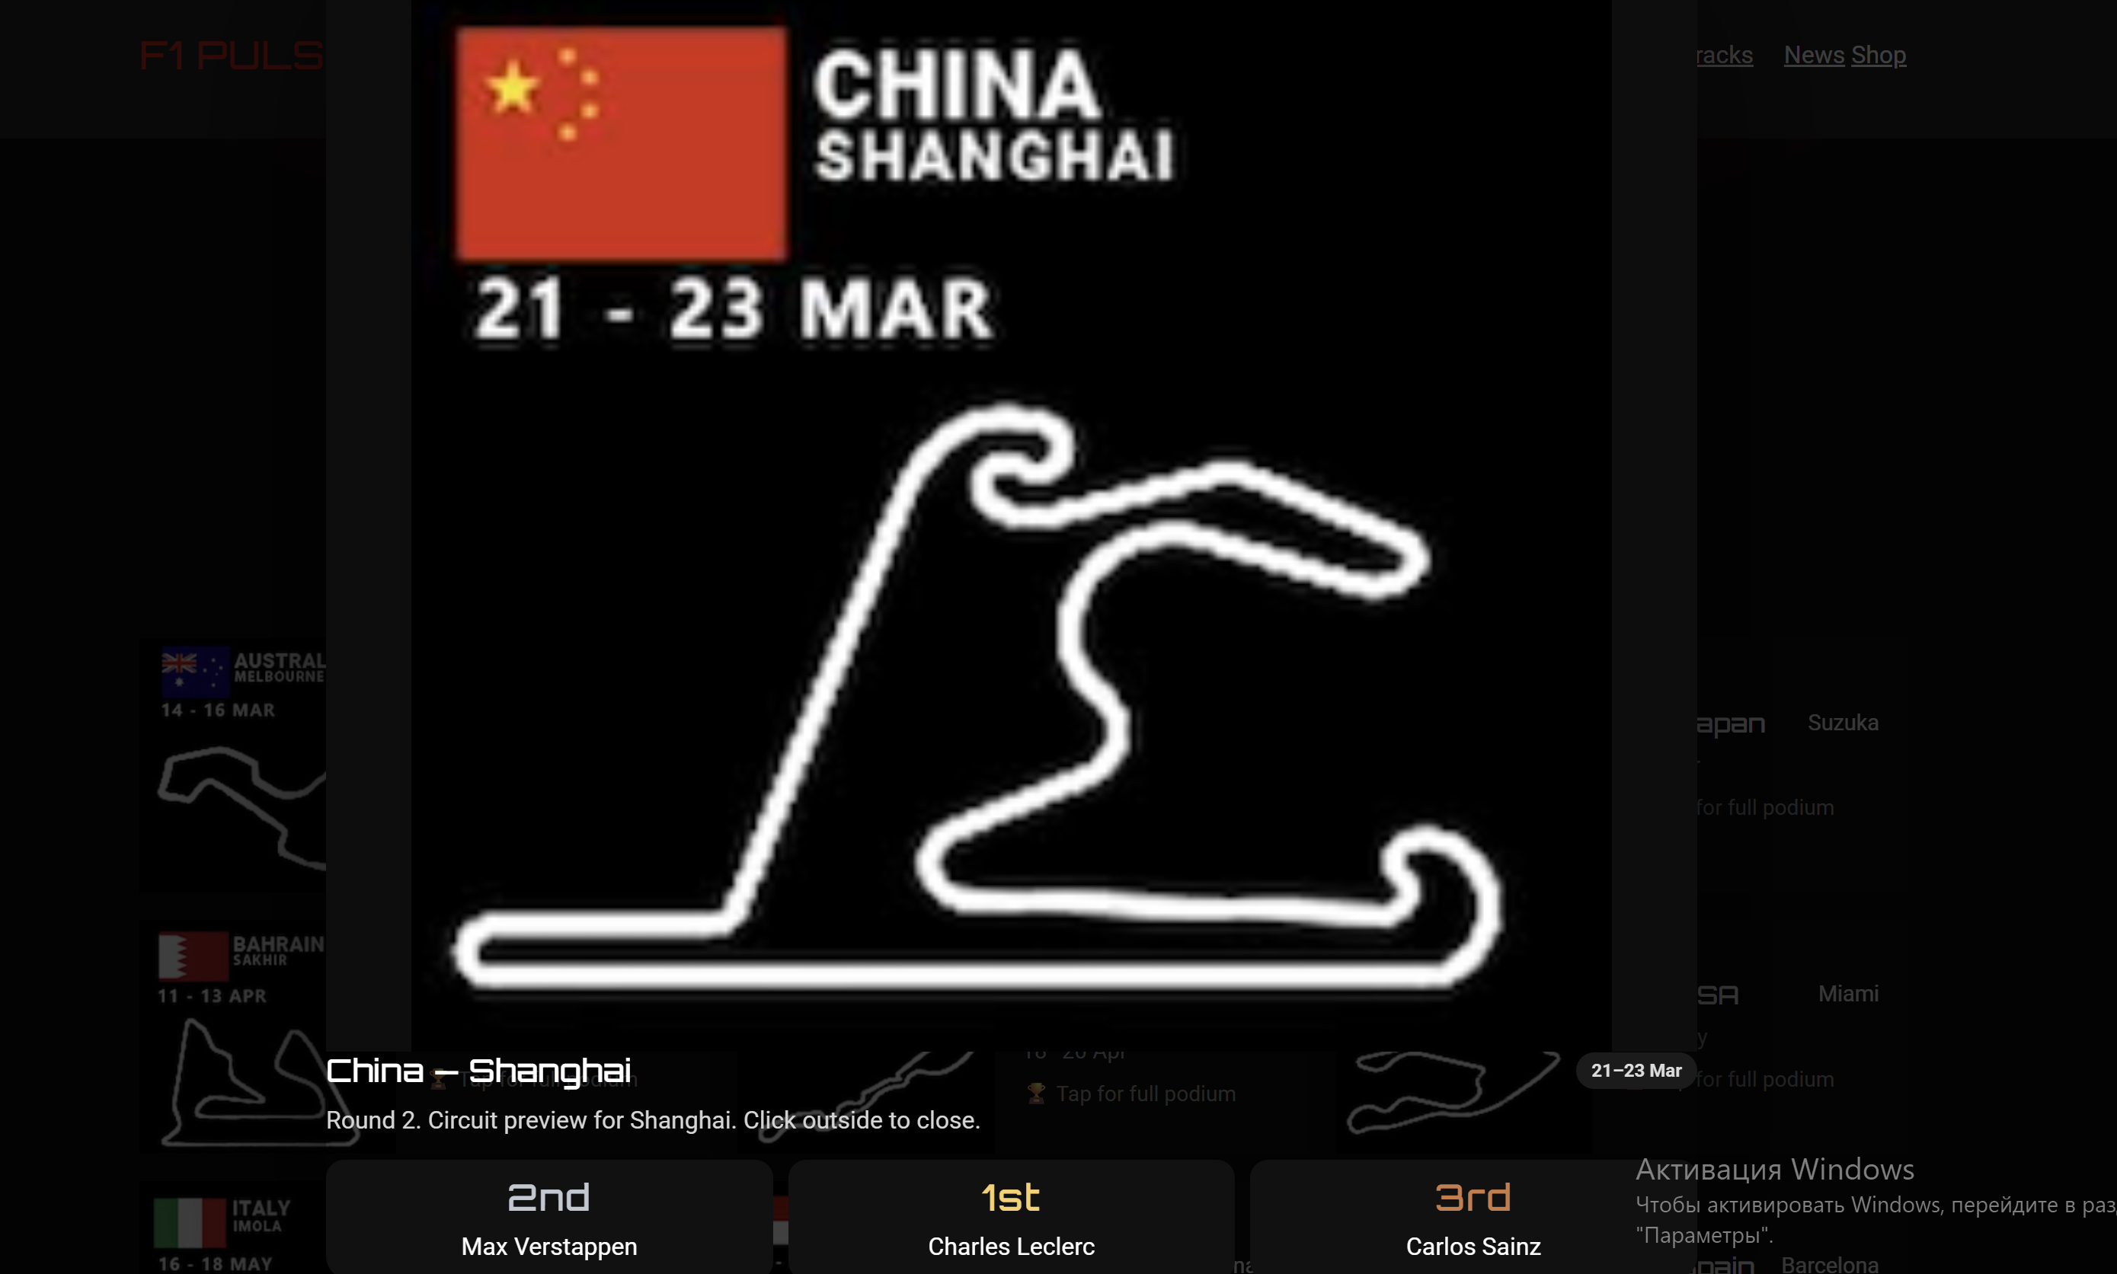

1. News Page (news.html):
   * Functionality: Lists upcoming Grand Prix events with a countdown timer. Includes a comment section with JavaScript form validation to ensure all fields are filled before submission.
   * Design: Clean and simple layout with a focus on readability and user interaction.

5 Shop (shop.html)

* Product Catalog: 23 F1 team-branded items (T-shirts, hoodies, caps, jackets, accessories)
* Category Filtering: Filter by "All", Men, Women, Kids, Headwear, or Gifts.
* Sorting: Toggle price sorting (low to high).
* Shopping Cart:
  + Add/remove items with size & quantity
  + Real-time subtotal, discount (30% off with coupon FITRACK), and total
  + Responsive cart panel with item thumbnails and controls (+/–, remove)
  + Authentication Simulation (Sign Up and Log In using **localStorage**)
* “Sign Up” stores user data locally (name, email, password).
* “Log In” checks credentials and redirects to a **Profile Page**.
* Profile page displays stored user details.
* Form Validation (Email format, Password length and complexity, Required fields, Phone number pattern and user-friendly error messages)
* Search or Filtering Functionality

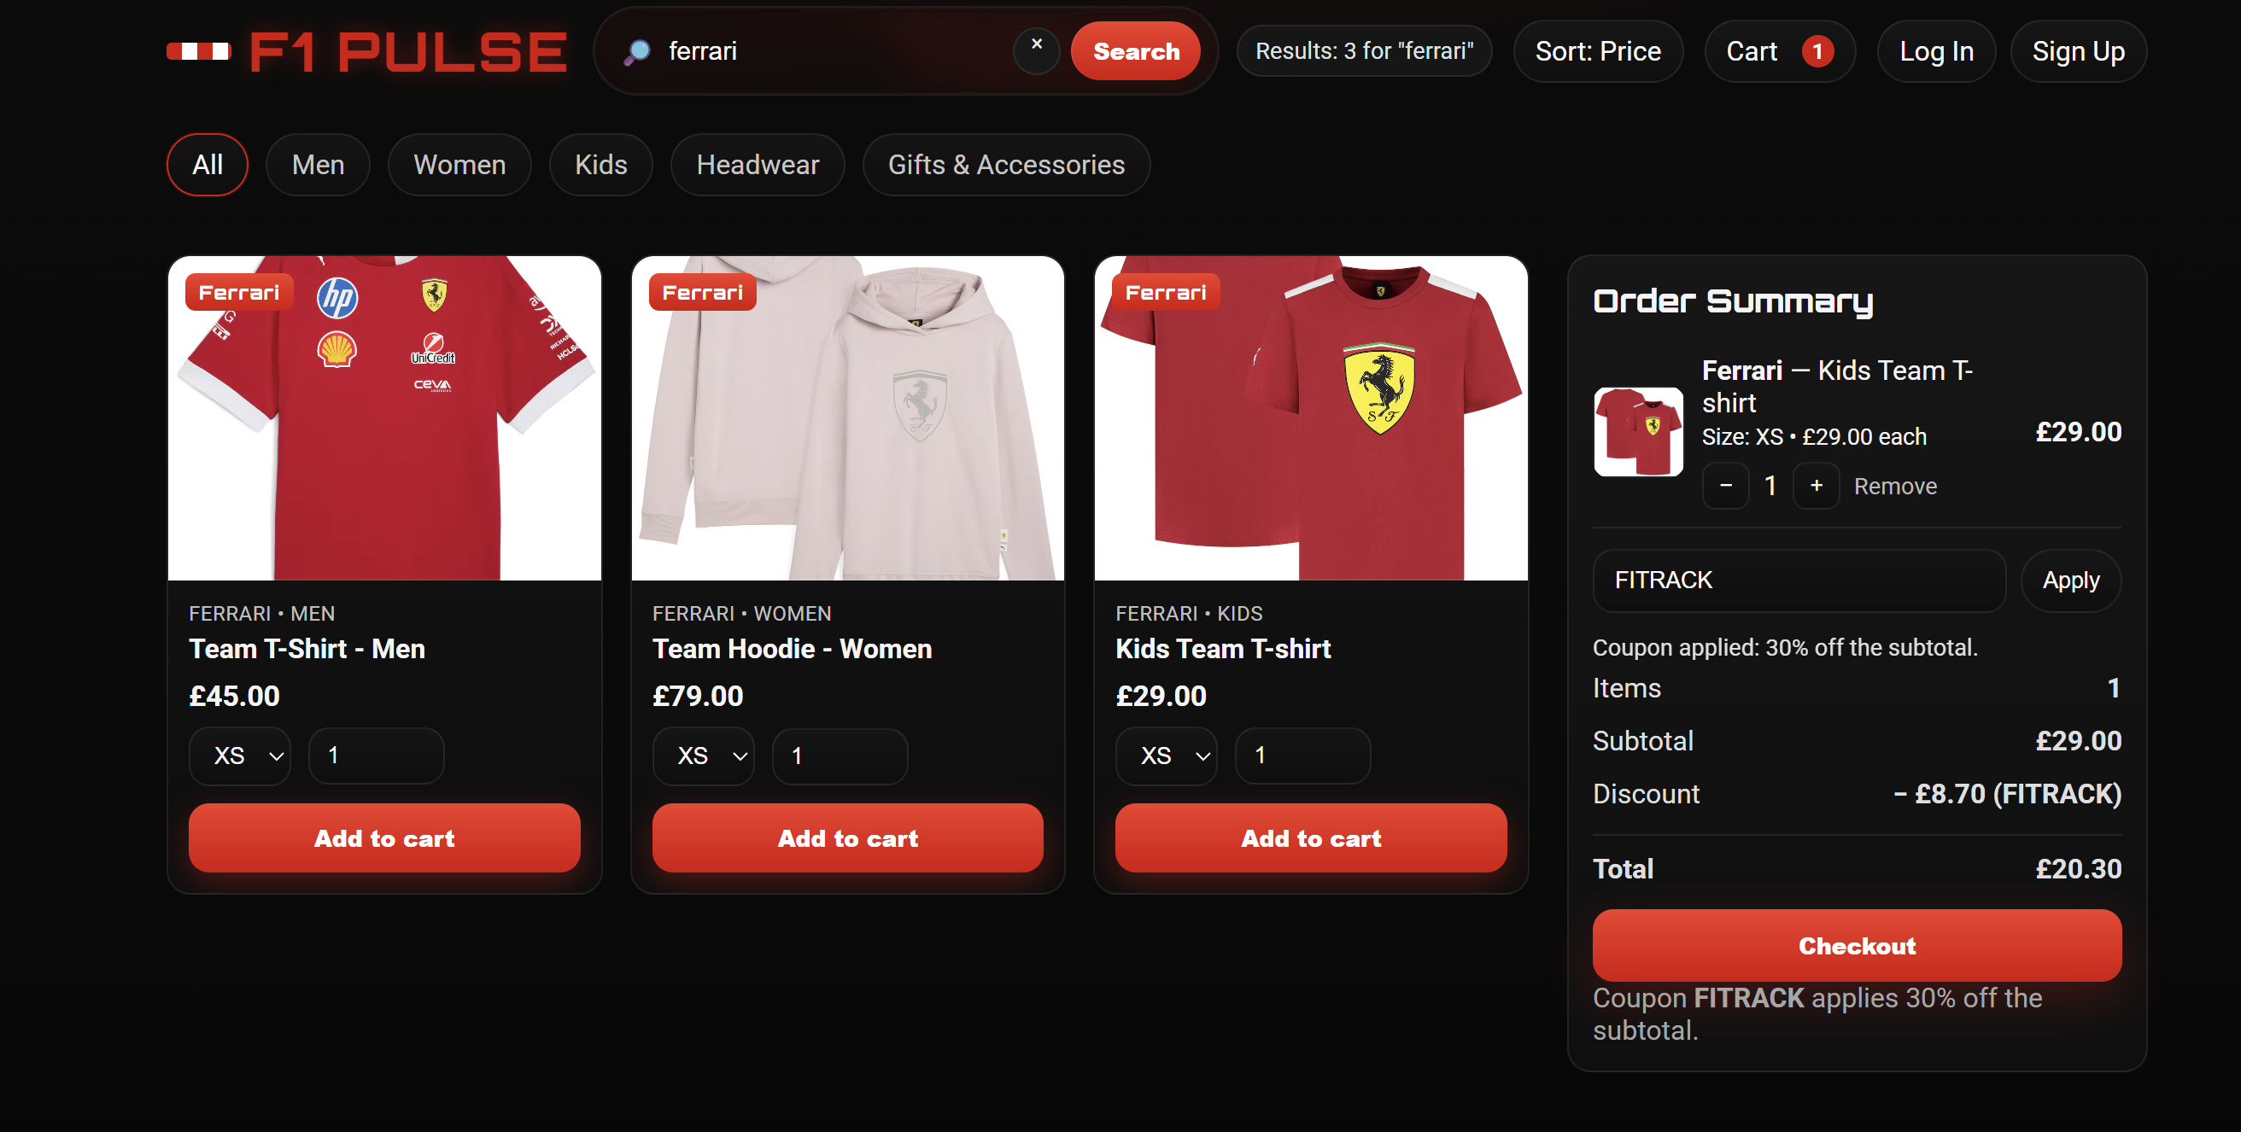

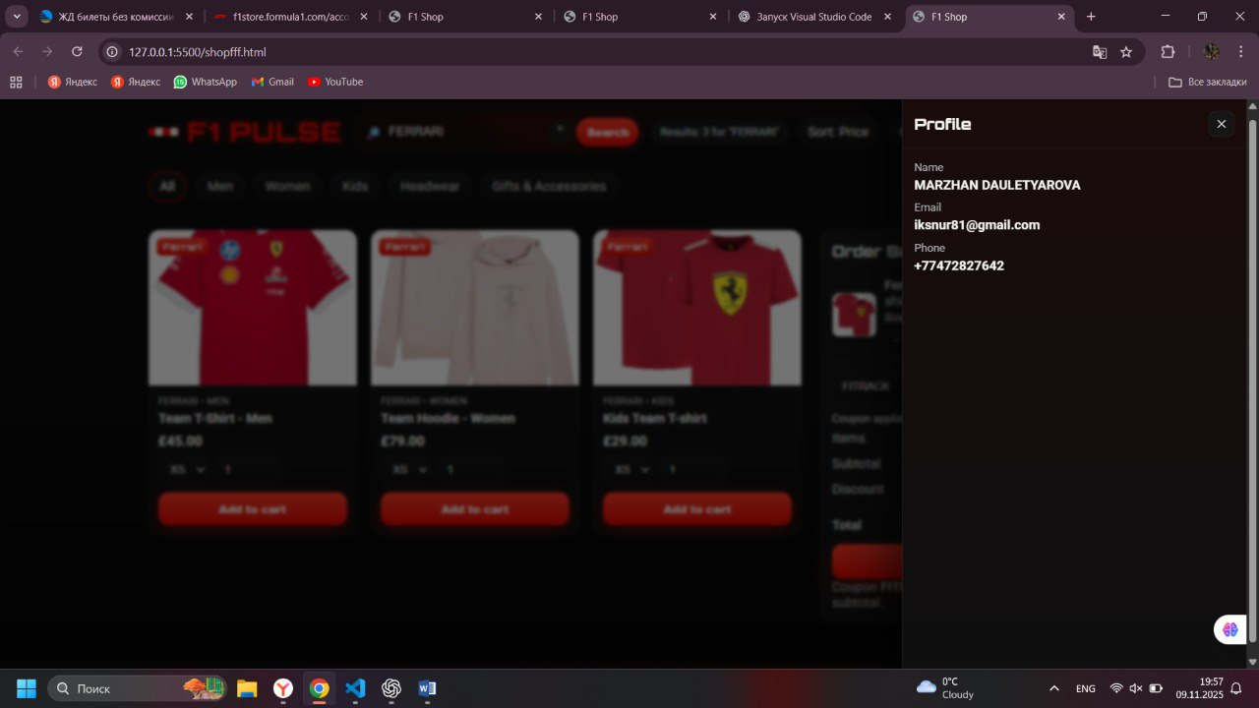

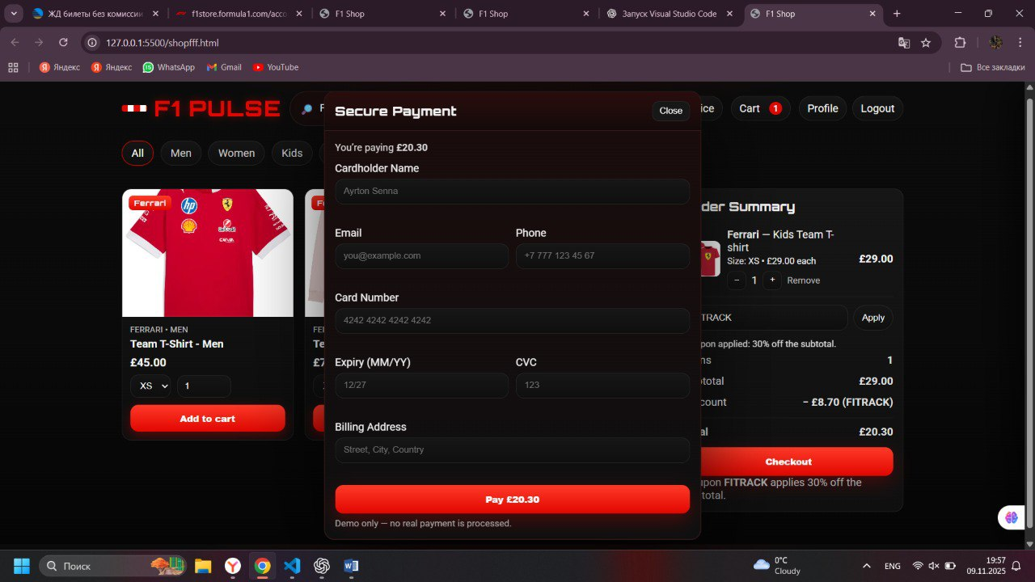

Key Decisions:

* Colour Scheme: A dark background (#0a0a0a) with F1 red (#e10600) as the primary accent colour was chosen to align with the finish line and create a dramatic, high-contrast interface.
* Typography: The futuristic Orbitron font is used for all headings and driver names to enhance the "classified dossier" theme, while the clean and readable Roboto font is used for body text.
* Responsiveness: The entire site is built with the Bootstrap 12-column grid system, ensuring that the layout adapts seamlessly to any screen size, from large desktops to small mobile phones.
* Interactivity: The project uses jQuery for smooth fade-in animations and vanilla JavaScript for dynamic content handling and form validation, fulfilling the assignment’s requirements for both technologies.

This structure and these features collectively create a cohesive, engaging, and fully functional interactive website that meets all the assignment’s criteria.

Thanks for reading that all!!!

### **2. Hosting**

* The final version must be **hosted online** (e.g., GitHub Pages, Netlify, or Vercel).
* Submit both the **live link** and **repository link**.
* All images, links, and pages must load correctly — no broken links or 404 errors.

### **3. Light and Dark Modes**

* Implement a **toggle switch** to allow users to switch between light and dark modes.
* The selected mode must stay consistent across pages (use localStorage if possible).
* Both modes must have proper contrast and maintain design readability.